

IRF 21/27

Gateway determination report – PP_2021_WINGE_002_00

Calwalla Reclassification, 340 Sheepwash Road, Glenquarry (0 homes and 0 jobs)

January 21

Published by NSW Department of Planning, Industry and Environment

[dpie.nsw.gov.au](http://www.dpie.nsw.gov.au/)

Title: Gateway determination report – PP_2021_WINGE_002_00

Subtitle: Calwalla Reclassification, 340 Sheepwash Road, Glenquarry (0 homes and 0 jobs)

© State of New South Wales through Department of Planning, Industry and Environment 2021. You may copy, distribute, display, download and otherwise freely deal with this publication for any purpose, provided that you attribute the Department of Planning, Industry and Environment as the owner. However, you must obtain permission if you wish to charge others for access to the publication (other than at cost); include the publication in advertising or a product for sale; modify the publication; or republish the publication on a website. You may freely link to the publication on a departmental website.  
  
Disclaimer: The information contained in this publication is based on knowledge and understanding at the time of writing (January 21) and may not be accurate, current or complete. The State of New South Wales (including the NSW Department of Planning, Industry and Environment), the author and the publisher take no responsibility, and will accept no liability, for the accuracy, currency, reliability or correctness of any information included in the document (including material provided by third parties). Readers should make their own inquiries and rely on their own advice when making decisions related to material contained in this publication.

Contents

1 Planning Proposal 1

1.1 Overview and objectives of planning proposal 1

1.2 Explanation of provisions 1

1.3 Site description and surrounding area 2

1.4 Mapping 2

2 Need for the planning proposal 2

3 Strategic assessment 4

3.1 Regional Plan 4

3.2 Local 4

3.3 Section 9.1 Ministerial Directions 5

3.4 State environmental planning policies (SEPPs) 5

4 Site-specific assessment 5

4.1 Environmental 5

4.2 Social and economic 5

4.3 Infrastructure 5

5 Consultation 6

5.1 Community 6

5.2 Agencies 6

6 Timeframe 6

7 Local plan-making authority 6

8 Assessment Summary 6

9 Recommendation 6

Table Reports and plans supporting the proposal

| Relevant reports and plans |
| --- |
| Planning Proposal (dated January 2021) |
| Deposited Plan |
| Title Search |
| Council Report – 26 August 2020 |
| Council Resolution – 26 August 2020 |

# Planning Proposal

## Overview and objectives of planning proposal

Table Planning proposal details

| LGA | LGA name |
| --- | --- |
| **PPA** | **Wingecarribee Shire Council** |
| **NAME** | **Calwalla Reclassification (0 homes and 0 jobs)** |
| **NUMBER** | **PP_2021_WINGE_001_00** |
| **LEP TO BE AMENDED** | **Wingecarribee Local Environmental Plan 2010** |
| **ADDRESS** | **340 Sheepwash Road, Glenquarry** |
| **DESCRIPTION** | **Lots 11-13 DP 1150964** |
| **RECEIVED** | **4/01/2021** |
| **FILE NO.** | **IRF21/27** |
| **POLITICAL DONATIONS** | **There are no donations or gifts to disclose and a political donation disclosure is not required** |
| **LOBBYIST CODE OF CONDUCT** | **There have been no meetings or communications with registered lobbyists with respect to this proposal** |

The planning proposal contains objectives and intended outcomes that adequately explain the intent of the proposal.

The objectives of the planning proposal are to:

* Reclassify the subject land from Community to Operational so that the classification is in line with the current and proposed ongoing uses.

The objectives of this planning proposal are clear and adequate.

## Explanation of provisions

The planning proposal seeks to amend the Wingecarribee LEP 2010 per the changes below:

Table Current and Proposed controls

| Control | Current | Proposed |
| --- | --- | --- |
| Reclassify land from Community to Operational | Community | Operational |

Council is not seeking to discharge any interests from the subject land, and it is not a Public Reserve.

The planning proposal contains an explanation of provisions that adequately explains how the objectives of the proposal will be achieved.

## Site description and surrounding area

The site is located at 340 Sheepwash Road, Glenquarry in the Wingecarribee local government area (lot 11-13 DP 1150964).

The land comprises three (3) lots and covers a total area of some 76.7 ha (Figure 1). The land is zoned E3 Environmental Management with a minimum lot size of 40 ha under Wingecarribee Local Environmental Plan 2010 (Wingecarribee LEP).

Most of the land is currently used by Council for the storage and disposal of treated effluent associated with the Robertson Sewerage Scheme. The land contains an effluent storage dam, pump house and access road to the property.

Some pockets of Southern Highland Shale Woodland are located on the subject land.

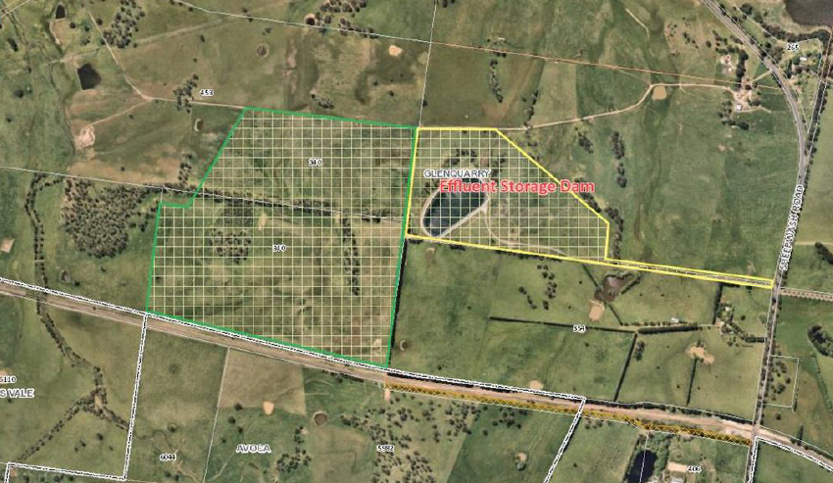

Figure Subject site (Source: Planning Proposal)

## Mapping

A new Reclassification Map will be required to be created as a result of the proposal.

The planning proposal does not include the reclassification map. As such, a condition is recommended requiring Council to prepare and exhibit draft maps with the planning proposal.

# Need for the planning proposal

The planning proposal is needed so that the classification of the land accurately reflects its current and proposed on-going uses.

Community land is land council makes available for use by the general public such as parks, reserves or sports grounds.

Most of the land is currently used by Council for the storage and disposal of treated effluent associated with the Robertson Sewerage Scheme. Council also intends to lease some 56% of the land (~394,300 m2) for a compatible agricultural purpose (Figure 2).

The area outlined in red in Figure 2 would be available for lease whilst the area in blue would continue to be used for irrigation and other works associated with the Robertson Sewerage Scheme. This area contains the fixed irrigators, Southern Highlands Shale Woodlands reserve, storage dam compound, and pump house.



Figure 2 Land use arrangements (Source: Planning Proposal)

Community land can only be leased if an adopted Plan of Management (PoM) is in place. There is no adopted PoM in place for the subject land.

Operational land is land which facilitates the functions of council such as a works depot or council garage, or in this case, to support the operations of the Robertson Sewerage System.

Given the existing and intended uses of the site, Council considers reclassification of the subject land to Operational land to be appropriate.

Council has also advised classification of public land generally occurs when it is first acquired by a council and classified as either community or operational. However, Council failed to resolve to classify the land within 3 months of the acquisition in 2010 and consequently it was automatically classified Community Land in accordance with section 31 of the *Local Government Act 1993*. Reclassification of the land must now occur to Operational to reflect its actual and intended uses.

The Department concurs the site would be more appropriately classified as Operational Land to reflect existing and proposed uses. The land is currently used for effluent disposal, there would be no loss of public open space and there is no intention for Council to dispose of or sell the land. Further, the proposal would allow the land to be better utilised for agricultural add-on uses.

A planning proposal of this nature is considered the best means of achieving the objectives and intended outcomes.

# Strategic assessment

## Regional Plan

The following table provides an assessment of the planning proposal against key relevant aspects of the South East and Tablelands Regional Plan.

Table Regional Plan assessment

| Regional Plan Objectives | Justification |
| --- | --- |
| Direction 5 | The proposal will promote agricultural innovation, sustainability and value-add opportunities. Irrigation systems utilising reclaimed water directly support this Direction. Further, compatible agricultural uses through lease arrangements will enhance environmental sustainability and value-add on opportunities. |
| Direction 8 | The proposal would enhance the value of agricultural land (as above) thereby protecting it. |
| Direction 14 | Council would continue to manage the areas of Southern Highland Shale Woodland within the irrigation lease area. Compatible agricultural uses negotiated through lease arrangements will seek to further enhance environmental sustainability of the broader site. |

## Local

The proposal states that it is consistent with the following local plans and endorsed strategies. It is also consistent with the strategic direction and objectives, as stated in the table below:

Table 4 Local strategic planning assessment

| Local Strategies | Justification |
| --- | --- |
| Wingecarribee Local Strategic Planning Statement | The planning proposal is consistent with key planning priorities identified in the LSPS relating to increasing energy water efficiencies (Planning Priority 1.1), ensuring growing communities supporting by essential infrastructure (e.g. Planning Priority 4.3 and 5.1) and agricultural land protection and innovation (Planning Priority 2.1). |
| Wingecarribee Community Strategic Plan | The planning proposal is consistent with goals and strategies contained within the CSP relating to:   * making well informed decisions and effectively managing assets (1.1 and 1.1.2); * ensuring safe, maintained and effective assets and Infrastructure (3.4); * managing and planning for future water, sewer and stormwater infrastructure needs (3.4.2); * protecting and enhancing Wingecarribee’s distinct and diverse natural environment (4.1); and * sustainably managing natural resources for broader community benefit (4.1.4) |

## Section 9.1 Ministerial Directions

The planning proposal’s consistency with relevant section 9.1 Directions is discussed below:

Table 5 Section 9.1 Ministerial Direction assessment

| Directions | Consistent/ Not Applicable | Reasons for Consistency or Inconsistency |
| --- | --- | --- |
| Direction 4.4 – Planning for Bushfire Protection | No | The land is partly mapped as bushfire prone land. As consultation has not occurred with the NSW Rural Fire Service (NSW RFS), the proposal is currently inconsistent with this Direction.  A condition is recommended requiring Council to consult with the NSW RFS prior to public exhibition. |
| Direction 5.2 – Sydney Drinking Water Catchment | Yes | No development would occur as a result of the proposal. As such, no negative water impacts are anticipated. |

## State environmental planning policies (SEPPs)

The planning proposal is not inconsistent with relevant SEPPs.

# Site-specific assessment

## Environmental

No additional environmental impacts would result from the continued use of the site for sewerage works. Council would continue to manage the areas of Southern Highland Shale Woodland within the irrigation lease area.

A detailed assessment of the proposed new agricultural uses on part of the site would be appropriately undertaken by Council at the development application stage.

## Social and economic

No negative social or economic impacts are anticipated as a result of the proposal.

## Infrastructure

No additional public infrastructure requirements or infrastructure impacts would result from reclassification. Conversely, the proposal will support the efficient operation of the Robertson Sewerage System.

A detailed assessment of the infrastructure and servicing requirements of the proposed new agricultural uses on part of the site would be appropriately undertaken by Council at the development application stage.

# Consultation

## Community

Council proposes a community consultation period of 28 days.

The exhibition period proposed is considered appropriate, and forms to the conditions of the Gateway determination.

## Agencies

Council proposes to consult with agencies as required under the Gateway determination.

It is recommended the following agencies be consulted on the planning proposal:

* Water NSW; and
* NSW Rural Fire Service

# Timeframe

Council proposes an 8 month time frame to complete the LEP.

The Department recommends a time frame of 9 months to ensure it is completed promptly in line with its commitment to reduce processing times.

A condition to the above effect is recommended in the Gateway determination.

# Local plan-making authority

Council has not requested to be the Local Plan-Making authority given it proposes reclassification of land.

However, as the planning proposal does not seek to discharge any interests or impact a public reserve, the Department recommends that Council be authorised to be the local plan-making authority for this proposal.

# Assessment Summary

The planning proposal is supported to proceed with conditions for the following reasons:

* it would result in a land classification which more appropriately reflects existing and proposed uses;
* it would not result in the loss of public open space; and
* it would allow the land to be better utilised for agricultural add-on uses.

Based on the assessment outlined in this report, the proposal must be updated before consultation to include a draft Reclassification Map.

# Recommendation

It is recommended the delegate of the Secretary:

* Agree that the planning proposal is consistent with all relevant section 9.1 Directions (except Direction 4.4); and
* Note that the consistency with section 9.1 Direction 4.4 – Planning for Bushfire Protection unresolved and will require justification.

It is recommended the delegate of the Minister determine that the planning proposal should proceed subject to the following conditions:

1. The planning proposal is to be updated prior to public exhibition to include:

* A Draft Reclassification Map.

1. Consultation is required with the following public authorities:

* Water NSW; and
* NSW Rural Fire Service (prior to public exhibition)

1. The planning proposal should be made available for community consultation for a minimum of 28 days.
2. The timeframe for completing the LEP is to be 9 months from the date of the Gateway determination.
3. Given the nature of the proposal, Council should be authorised to be the local plan-making authority.

25/01/21

Graham Towers

Manager, Southern Region

27/01/2021

Sarah Lees

Director, Southern Region

Assessment officer

Andrew Hartcher

Specialist Planner, Southern Region

4247 1823

Attachment A – Planning Proposal

Attachment B – Gateway determination

Attachment C – Letter to Council